**Task#1:**

**Q.Design this pages quickely bootstrap**

* **Index..html:**

|  |
| --- |
| **<!DOCTYPE html>**  **<html lang="en">**  **<head>**  **<meta charset="UTF-8">**  **<title>2 Column Layout</title>**  **<linkhref="https://cdn.jsdelivr.net/npm/bootstrap@5.3.0/dist/css/bootstrap.min.css" rel="stylesheet">**  **</head>**  **<body> <div class="bg-warning p-4">**  **<h3>Website Name</h3>  </div>**  **<div class="bg-light px-3 py-2">**  **<a href="#">Home</a> |**  **<a href="#">About Us</a> |**  **<a href="#">Gallery</a> |**  **<a href="#">Contact Us</a> </div>**  **<div class="container mt-3">**  **<div class="row">**  **<div class="col-md-8">**  **<h4>Sub heading</h4>**  **<p>Lorem ipsum dolor sit amet, consectetur adipiscing elit...</p>**  **<p>Fusce consequat porttitor nisl...</p </div>**  **<div class="col-md-4 bg-info bg-opacity-25 p-3">**  **<ul>**  **<li><a href="#">Home</a></li>**  **<li><a href="#">About Us</a></li>**  **<li><a href="#">Gallery</a></li>**  **<li><a href="#">Contact Us</a></li> </ul>  </div  </div> </div>**  **<div class="bg-secondary text-white text-center py-2 mt-3">**  **Websiteabdullah </div>**  **</body>**  **</html>** |

**OUTPUT:**

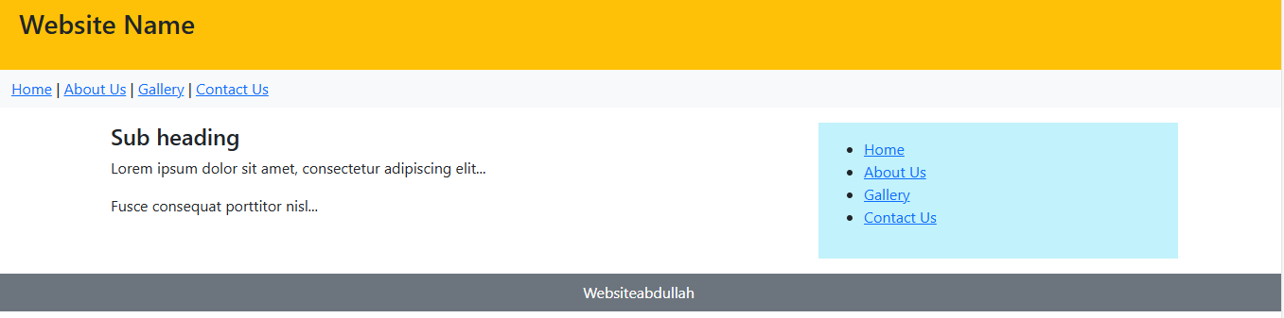

* **Index_2.html:**

|  |
| --- |
| **<!DOCTYPE html>**  **<html lang="en">**  **<head>**  **<meta charset="UTF-8">**  **<title>3 Column Layout</title>**  **<linkhref="https://cdn.jsdelivr.net/npm/bootstrap@5.3.0/dist/css/bootstrap.min.css" rel="stylesheet">**  **</head>**  **<body>**  **<div class="container mt-3">**  **<div class="row">**  **<div class="col-md-3 bg-light p-3">**  **<h5>Sidebar</h5>**  **<a href="#">Link 1</a><br>**  **<a href="#">Link 2</a><br>**  **<a href="#">Link 3</a>**  **</div>**  **<div class="col-md-6 bg-success bg-opacity-25 p-3">**  **<h5>Main Content</h5>**  **<p>Lorem ipsum dolor sit amet...</p>**  **<p>Lorem ipsum dolor sit amet...</p>**  **<p><strong>Important Note</strong><br>Lorem ipsum dolor sit amet...</p>**  **</div>**  **<div class="col-md-3 bg-warning bg-opacity-25 p-3">**  **<h5>Right Sidebar</h5>**  **<a href="#">Link A</a><br>**  **<a href="#">Link B</a><br>**  **<a href="#">Link C</a>**  **</div>**  **</div>**  **</div>**  **</body>**  **</html>** |

OUTPUT:

